CS340 README Project 2
Benjamin Holcomb

Project overview
This project is a Python dashboard that helps Grazioso Salvare identify animal shelter dogs that may be suitable for search-and-rescue training. The dashboard retrieves Austin Animal Center Outcomes records from MongoDB and lets users filter them by rescue type.
The dashboard provides four filter options: Water Rescue, Mountain or Wilderness Rescue, Disaster or Individual Tracking, and Reset. The results appear in an interactive data table, a geolocation map for the selected animal, and a pie chart showing the breed distribution of the displayed records.
Functionality
- Displays animal records from MongoDB in a paginated, sortable table.
- Filters records by breed, sex, and age criteria for each rescue category.
- Resets the view to show all records.
- Updates the breed pie chart and map based on the table data.
- Displays the Grazioso Salvare logo and the dashboard creator’s name.
Screenshots
Starting state — all animals
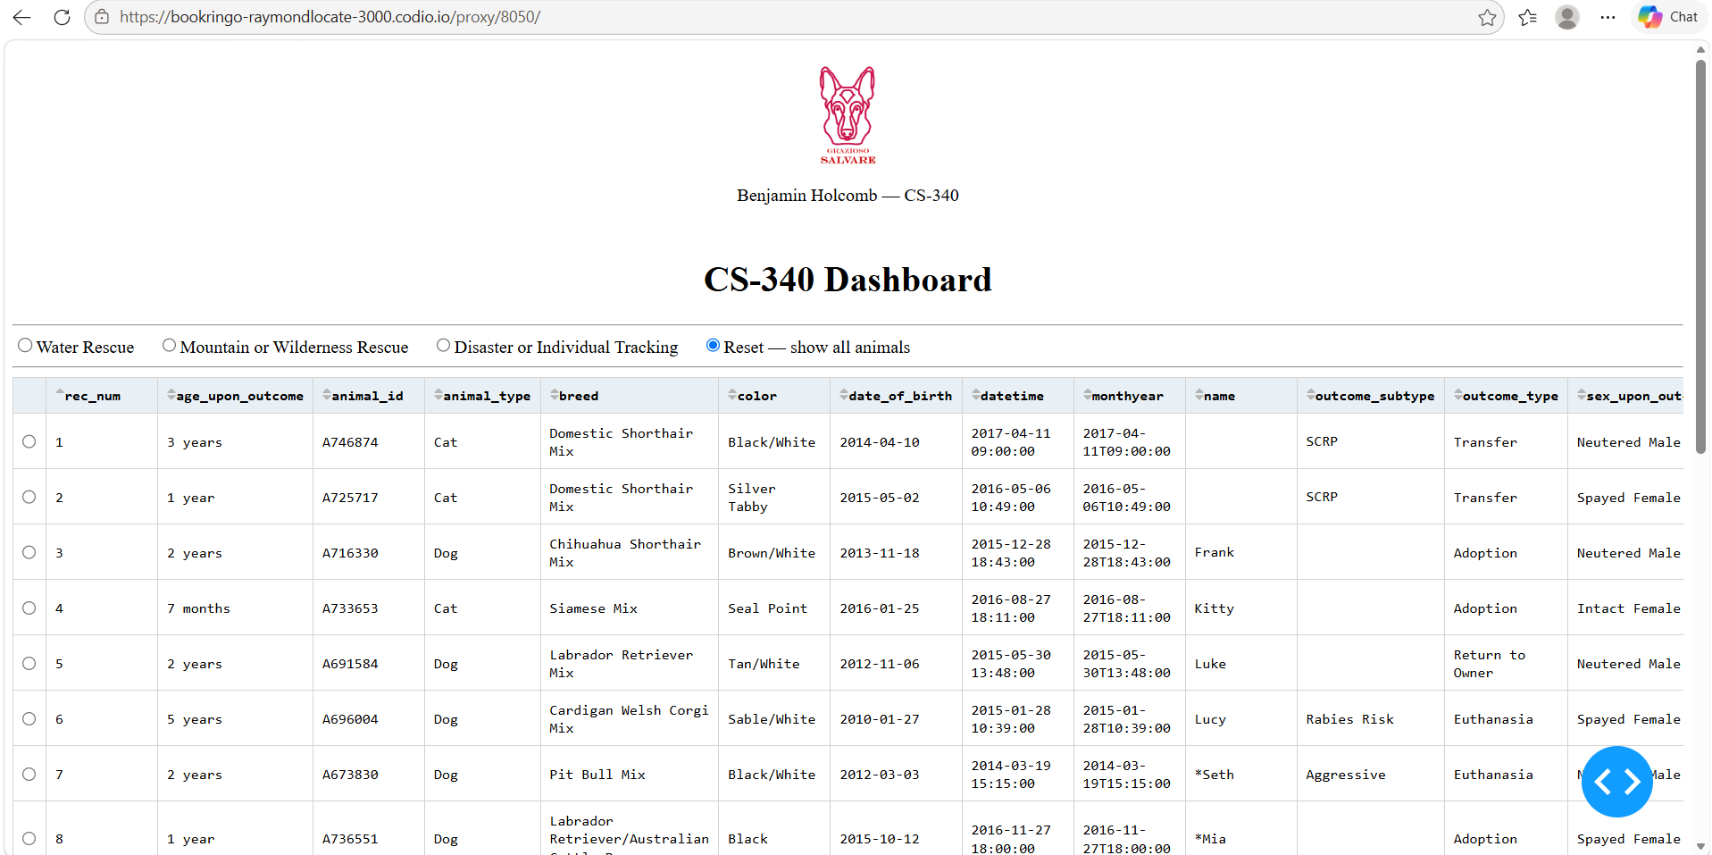
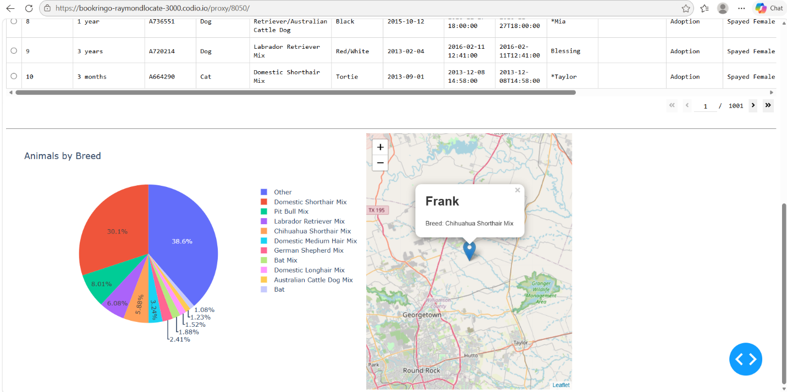
Water Rescue
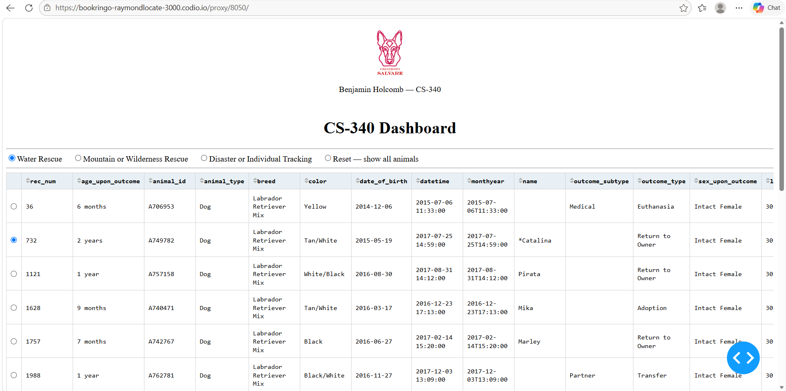
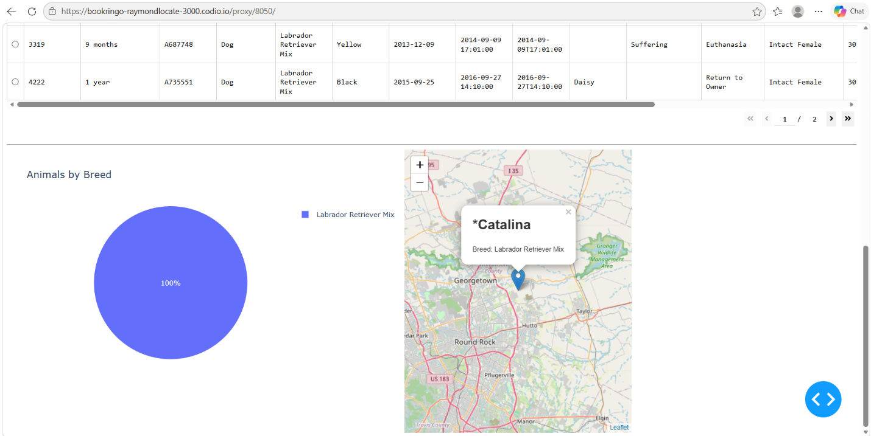
Mountain or Wilderness Rescue
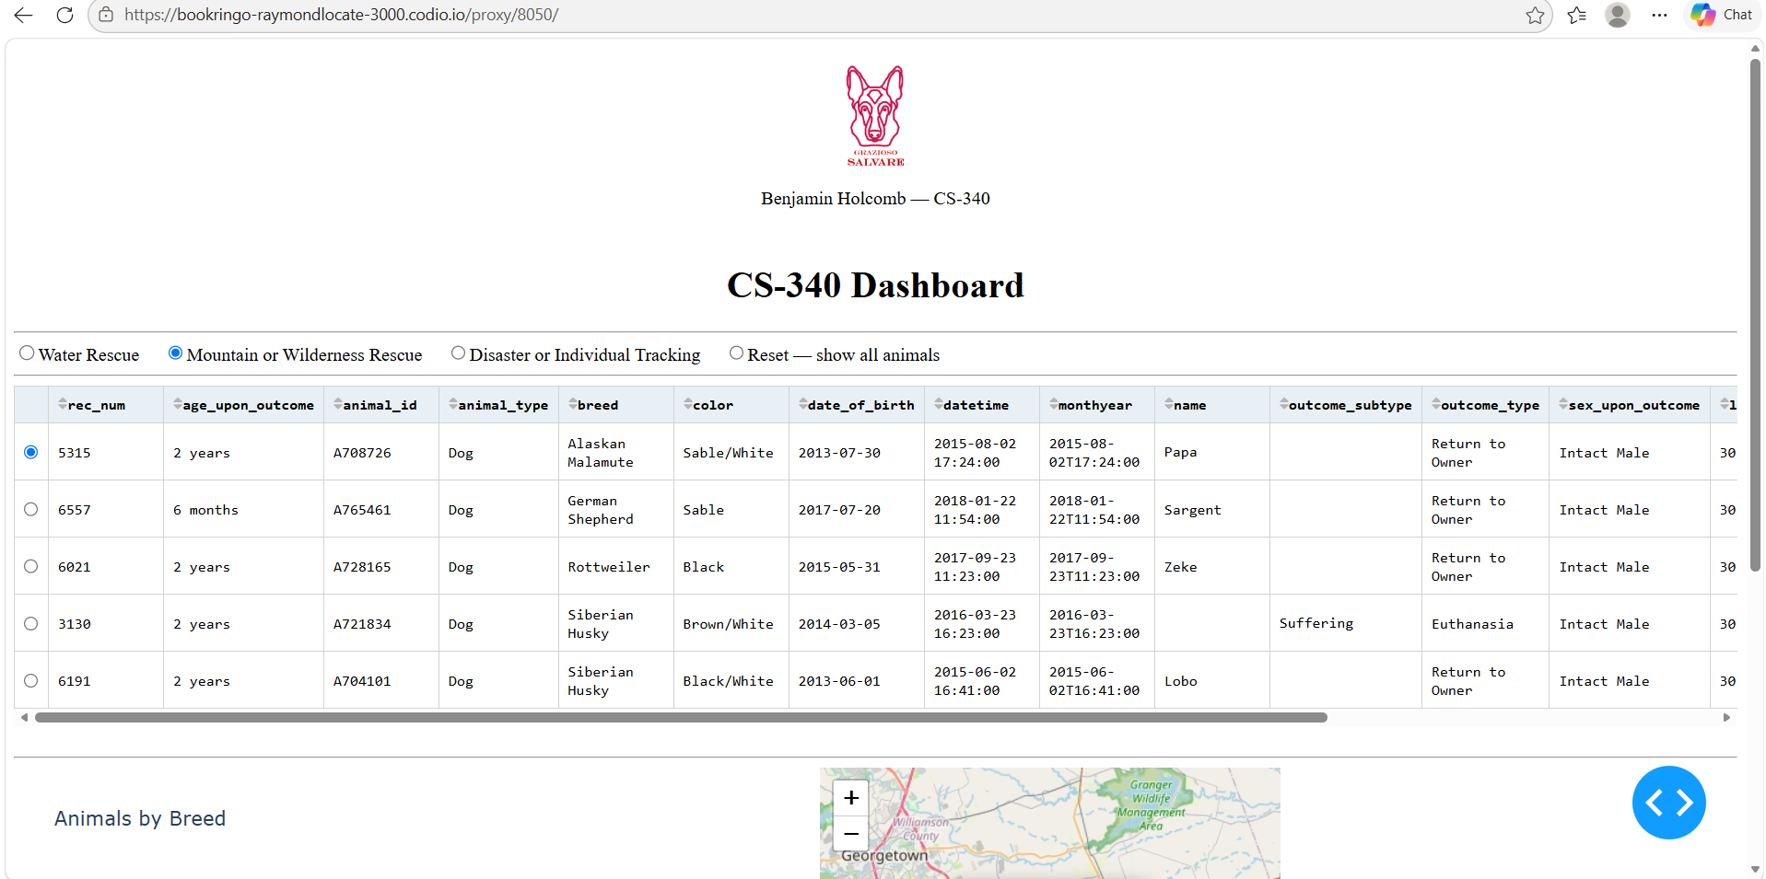

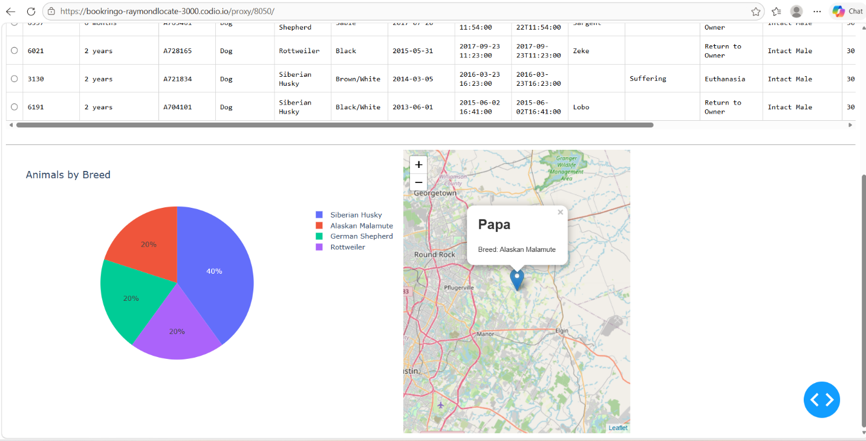
Disaster or Individual Tracking
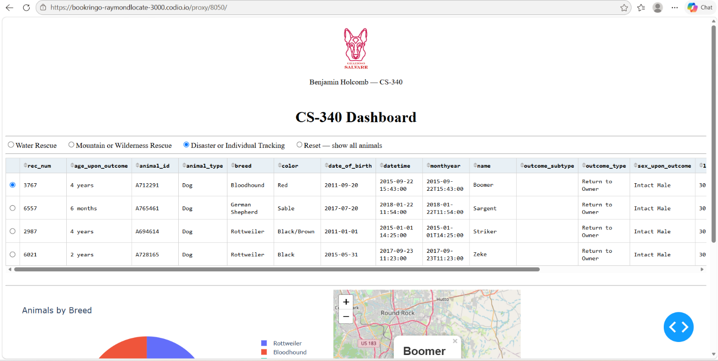
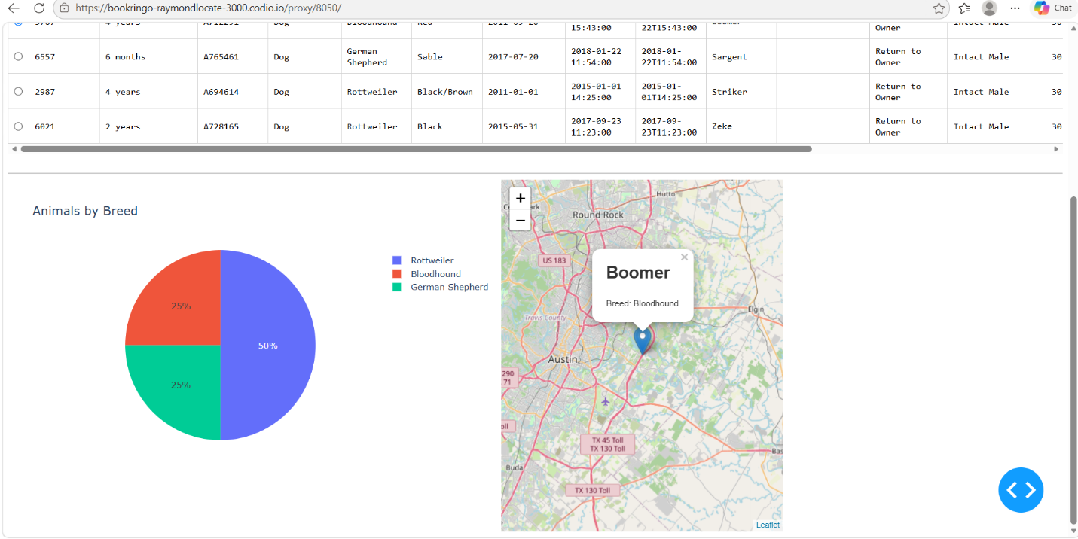

Tools and rationale
- Python implements the dashboard and database access logic.
- MongoDB stores the shelter animal records. Its document-based structure works well with Python dictionaries and supports queries on fields such as breed, sex, and age.
- PyMongo, used by the CRUD module, provides the Python interface for communicating with MongoDB.
- Dash and JupyterDash provide the interactive web dashboard. Dash components handle the filter controls, table, map, and chart; callbacks connect user selections to updated data.
- Pandas converts retrieved records into DataFrames for preparing data for the table and chart.
- Plotly Express creates the breed pie chart.
- Dash Leaflet displays the animal’s location on a map.
Project files
- ProjectTwoDashboard.ipynb — dashboard layout, filters, callbacks, table, map, and chart.
- CRUD_Python_Module.py — MongoDB connection and CRUD methods.
- Grazioso Salvare Logo.png — dashboard logo.
Reproducing the project
- Install Python and the required packages in an environment that can access MongoDB. The dashboard uses jupyter_dash, dash, dash_leaflet, plotly, pandas, numpy, and matplotlib; the CRUD module also requires pymongo.
- Place the notebook, CRUD module, and logo image in the appropriate working directory. Confirm that the notebook’s logo filename and CRUD import match the actual filenames.
- Make sure MongoDB is running, the animal shelter database and collection are available, and the configured account has permission to read the records.
- Update the database connection details in CRUD_Python_Module.py or the notebook as appropriate for the environment. Avoid publishing real credentials in a public repository.
- Open and run ProjectTwoDashboard.ipynb in Jupyter. Run the notebook cells in order.
- Use each filter option and confirm that the table, pie chart, and map update. Select Reset to return to the unfiltered records.
Development steps
- Connected the dashboard to MongoDB through the previously developed CRUD Python module.
- Retrieved the animal records and displayed them in a sortable, paginated table.
- Added filter controls and MongoDB queries based on the client’s rescue categories.
- Connected the table, map, and pie chart to the selected filter results.
- Tested the dashboard in its unfiltered and filtered states and captured screenshots for documentation.
Challenges and resolutions
One dashboard layout issue was that the map initially appeared too small. Its width and height were increased so it could fill its dashboard column and remain readable.
The dashboard also needs valid latitude and longitude values to display a marker. During testing, records should be checked for missing or invalid coordinates so those records do not prevent the map from rendering.
Resources
- Dash documentation
- Plotly Express documentation
- Dash Leaflet documentation
- MongoDB PyMongo documentation
- Pandas documentation

